Recruitment Webpage Template
EXAMPLE
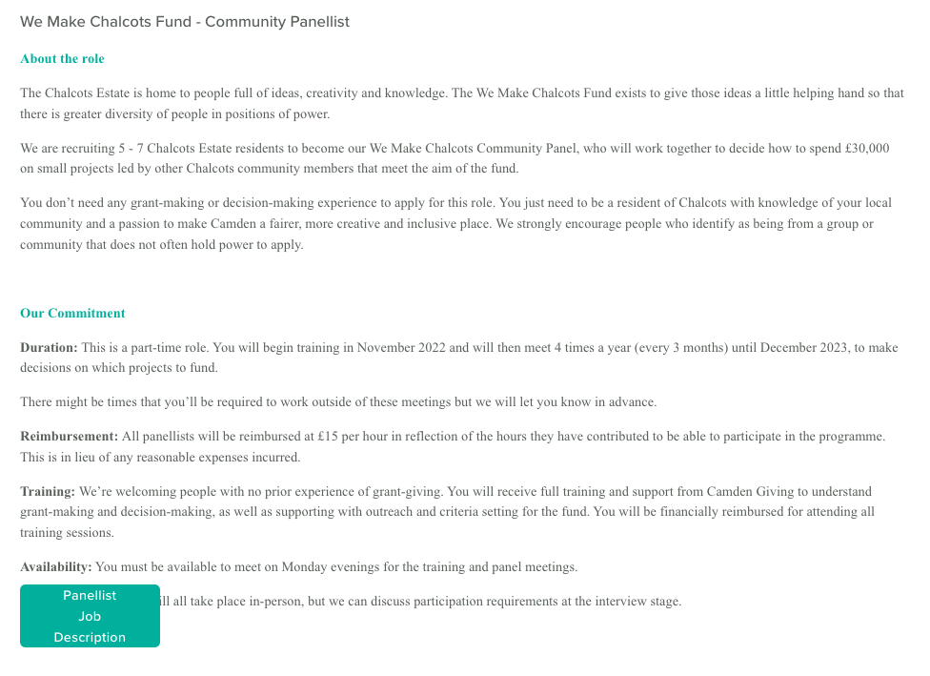
To Apply
Send us EITHER:
- WhatsApp
- Text Message
- Video
- Voice Note
- Email
to [INSERT PHONE NUMBER] or [INSERT EMAIL] telling us:

- Your Name, Contact Details (email & number)
- Postcode
- Answer ANY ONE of these:
  - Why do [e.g young people’s voices matter]?
  - What does being a [e.g young person in Camden mean]?
  - What are your biggest barriers and what empowers you?

